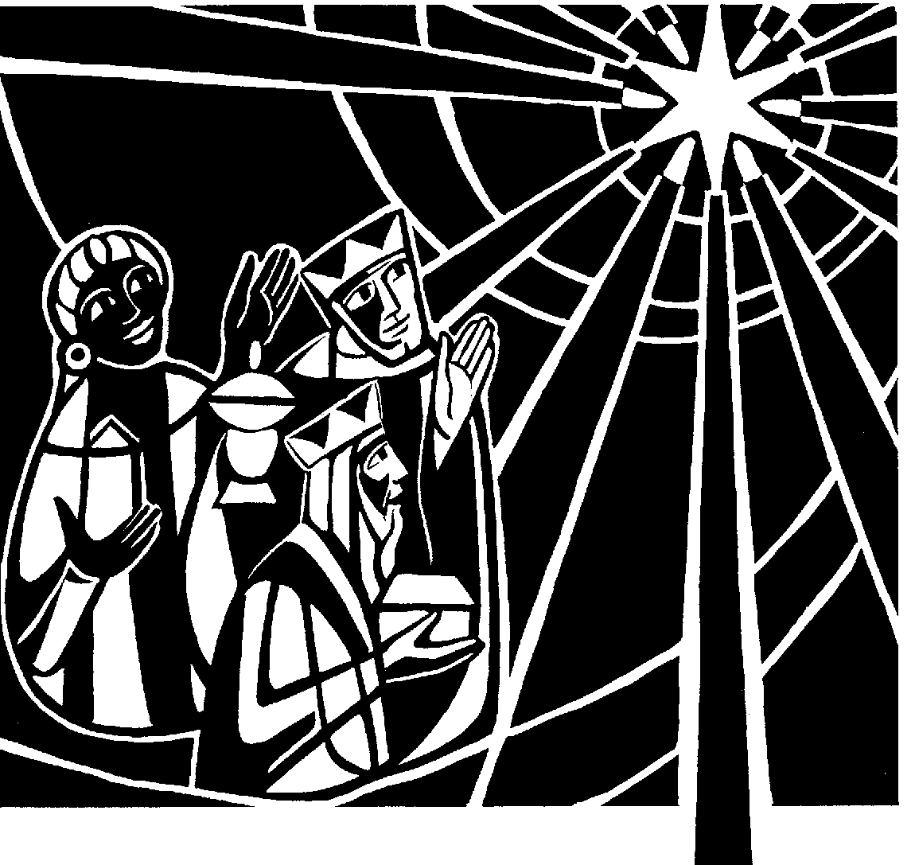

St Andrew's Church

Orford with Longford

**Epiphany**

**6th January 2019**

**THE GATHERING**

**Introit hymn:** 89‘O worship the Lord in the beauty of holiness’

Priest: In the name of the Father and of the Son and of the Holy Spirit. **Amen**

Priest: Blessed are you, Lord our God, King of the Universe!

All: From the rising of the sun to its setting

your name is proclaimed in all the world.

Priest: The Lord of glory be with you.

All: The Lord bless you.

All: Almighty God, to whom all hearts are open, all desires known, and from whom no secrets are hidden: cleanse the thoughts of our hearts by the inspiration of your Holy Spirit, that we may perfectly love you, and worthily magnify your holy name; through Christ our Lord. Amen.

Priest: The grace of God has dawned upon the world through our Saviour Jesus Christ, who sacrificed himself for us to purify a people as his own. Let us confess our sins.

(After a period of silent reflection)

All: Most merciful God, Father of our Lord Jesus Christ, we confess that we have sinned in thought, word and deed. We have not loved you with our whole heart. We have not loved our neighbours as ourselves. In your mercy forgive what we have been, help us to amend what we are, and direct what we shall be; that we may do justly, love mercy, and walk humbly with you, our God. Amen.

Priest: Almighty God, who forgives all who truly repent, have mercy upon you, pardon and deliver you from all your sins, confirm and strengthen you in all goodness, and keep you in life eternal; through Jesus Christ our Lord. **Amen.**

**All Glory to God in the highest, and peace to his people on earth. Lord**

**God, heavenly King, almighty God and Father, we worship you, we give you thanks, we praise you for your glory. Lord Jesus Christ, only Son of the Father, Lord God, Lamb of God, you take away the sin of the world: have mercy on us; you are seated at the right hand of the Father: receive our prayer. For you alone are the Holy One, you alone are the Lord, you alone are the Most High, Jesus Christ, with the Holy Spirit, in the glory of God the Father. Amen.**

**The Collect:** O God, who by the leading of a star manifested your only Son to the peoples of the earth: mercifully grant that we, who know you now by faith, may at last behold your glory face to face; through Jesus Christ our Lord, who is alive and reigns with you, in the unity of the Holy Spirit, one God, now and for ever. **Amen**

#### **THE LITURGY OF THE WORD**

**A reading from the book of the prophet Isaiah** *(Isa 60.1–6)*

Arise, shine; for your light has come, and the glory of the Lord has risen upon you. For darkness shall cover the earth, and thick darkness the peoples; but the Lord will arise upon you, and his glory will appear over you. Nations shall come to your light, and kings to the brightness of your dawn. Lift up your eyes and look around; they all gather together, they come to you; your sons shall come from far away, and your daughters shall be carried on their nurses’ arms. Then you shall see and be radiant; your heart shall thrill and rejoice, because the abundance of the sea shall be brought to you, the wealth of the nations shall come to you. A multitude of camels shall cover you, the young camels of Midian and Ephah; all those from Sheba shall come. They shall bring gold and frankincense, and shall proclaim the praise of the Lord.

This is the word of the Lord.

All: Thanks be to God.

**Hymn:**  83 ‘As with gladness men of old’

**A reading from the letter of Paul to the Ephesians** *(Eph 3.1–12)*

I Paul, am a prisoner for Christ Jesus for the sake of you Gentiles – for surely you have already heard of the commission of God’s grace that was given me for you, and how the mystery was made known to me by revelation, as I wrote above in a few words, a reading of which will enable you to perceive my understanding of the mystery of Christ. In former generations this mystery was not made known to humankind, as it has now been revealed to his holy apostles and prophets by the Spirit: that is, the Gentiles have become fellow-heirs, members of the same body, and sharers in the promise in Christ Jesus through the gospel. Of this gospel I have become a servant according to the gift of God’s grace that was given me by the working of his power. Although I am the very least of all the saints, this grace was given to me to bring to the Gentiles the news of the boundless riches of Christ, and to make everyone see what is the plan of the mystery hidden for ages in God who created all things; so that through the church the wisdom of God in its rich variety might now be made known to the rulers and authorities in the heavenly places. This was in accordance with the eternal purpose that he has carried out in Christ Jesus our Lord, in whom we have access to God in boldness and confidence through faith in him.

This is the word of the Lord.

All: Thanks be to God.

**Gradual hymn:** 85 ‘Earth has many a noble city’

##### THE GOSPEL

Priest Christ was revealed in flesh,

proclaimed among the nations and believed in throughout the world.

**All 🎜 Alleluia, alleluia, alleluia, alleluia. Alleluia, alleluia, alleluia.**

Hear the gospel of our Lord Jesus Christ according to Matthew *(Matt 2.1–12)*

All 🎜 Glory to you, O Lord

In the time of King Herod, after Jesus was born in Bethlehem of Judea, wise men from the East came to Jerusalem, asking, ‘Where is the child who has been born king of the Jews? For we observed his star at its rising, and have come to pay him homage.’ When King Herod heard this, he was frightened, and all Jerusalem with him; and calling together all the chief priests and scribes of the people, he inquired of them where the Messiah was to be born. They told him, ‘In Bethlehem of Judea; for so it has been written by the prophet: “And you, Bethlehem, in the land of Judah, are by no means least among the rulers of Judah; for from you shall come a ruler who is to shepherd my people Israel.”’ Then Herod secretly called for the wise men and learned from them the exact time when the star had appeared. Then he sent them to Bethlehem, saying, ‘Go and search diligently for the child; and when you have found him, bring me word so that I may also go and pay him homage.’ When they had heard the king, they set out; and there, ahead of them, went the star that they had seen at its rising, until it stopped over the place where the child was. When they saw that the star had stopped, they were overwhelmed with joy. On entering the house, they saw the child with Mary his mother; and they knelt down and paid him homage. Then, opening their treasure-chests, they offered him gifts of gold, frankincense, and myrrh. And having been warned in a dream not to return to Herod, they left for their own country by another road.

This is the Gospel of the Lord

**All 🎜 Praise to you, O Christ**

*The Wise Men are brought to the stable one at a time. As each is placed by the Crib, a short prayer follows, which ends:* **“Blessed be God for ever!”**

**We three kings** of orient are;

Bearing gifts, we traverse afar

Field and fountain, moor and mountain,

Following yonder star:

*O star of wonder, star of night,*

*Star with royal beauty bright,*

*Westward leading, still proceeding,*

*Guide us to thy perfect light.*

***The first wise man is brought and placed in the Crib as we sing:***

Born a king on Bethlehem plain,

Gold I bring to crown him again

King for ever, ceasing never,

Over us all to reign:

*O star of wonder ...*

*Prayer, ends …*acceptable in the service of your kingdom.

**All: Blessed be God for ever!**

***The second wise man is brought and placed in the Crib as we sing:***

Frankincense to offer have I;

Incense owns a deity nigh:

Prayer and praising, all men raising,

Worship him, God most high:

*O star of wonder ...*

*Prayer, ends …*to offer ourselves in your priestly service.

**All: Blessed be God for ever!**

***The third wise man is brought and placed in the Crib as we sing:***

Myrrh is mine; its bitter perfume

Breathes a life of gathering gloom;

Sorrowing, sighing, bleeding, dying,

Sealed in the stone-cold tomb:

*O star of wonder ...*

*Prayer, ends …*that we may be the first-fruits of your new creation.

**All: Blessed be God for ever!**

Glorious now, behold him arise,

King, and God, and sacrifice!

Heav'n sings alleluia

Alleluia the earth replies:

*O star of wonder ...*

The Sermon *(please sit)*

Priest: We believe in one God, **the Father, the almighty, maker of heaven and earth, of all that is, seen and unseen.**

We believe in one Lord, Jesus Christ, the only Son of God, eternally begotten of the Father, God from God, Light from Light, true God from true God, begotten, not made, of one Being with the Father; through him all things were made. For us and for our salvation he came down from heaven, was incarnate from the Holy Spirit and the Virgin Mary and was made man. For our sake he was crucified under Pontius Pilate; he suffered death and was buried.

On the third day he rose again in accordance with the Scriptures; he ascended into heaven and is seated at the right hand of the Father. He will come again in glory to judge the living and the dead, and his kingdom will have no end.

We believe in the Holy Spirit, the Lord, the giver of life, who proceeds from the Father and the Son, who with the Father and the Son is worshipped and glorified, who has spoken through the prophets. We believe in one holy catholic and apostolic Church. We acknowledge one baptism for the forgiveness of sins. We look for the resurrection of the dead, and the life of the world to come.

Amen.

Priest: Today the Wise Men knelt before our Saviour. Let us also kneel to worship him with great joy, and to make our prayer to his heavenly Father.

*Each section ends:* Lord, in your mercy.

**All: Hear our prayer.**

**Please remember in your prayers:**

**those who are ill:**  (4) Mary Lowe, Jenson Wright, Zenia, Karen Wilkinson, Joan Clegg, Norma Lee (3)Rob Mudd, Mark Shepherd, Marion Greatorex, Barbara Boscoe, Eileen Whitehead, Jacqueline Willington, Stephen Rawling, Stan Brand, Beryl Bentley (2) Vera Wood, Peter O’Connor, Maria Parkinson (1) Lynn Burman, Michael Stringer, Michelle Smith, Paul Hogden, Joyce Hetherington, Michael Thackeray, Pauline Smith, Callum Foy, Gladys Gardner

* **those who have died:** Wendy Edwards, Trent Tinsley-Wynn, Tom Wilcock

* **those whose year's mind falls at this time**:

***Sunday:*** Betty Hilton

***Monday:*** May Blackmore, Joan Greatorex, Ivan Holloway

***Tuesday:*** Ernest Best, Mary Cooper

***Wednesday:*** Albert Best, Lily Richards

***Thursday:*** Peter Gosling, Lily Unsworth

***Friday:*** Cyril Lees

After the final petition:

Leader: Merciful Father,

**accept these prayers**

**for the sake of your Son,**

**our Saviour Jesus Christ. Amen.**

THE LITURGY OF THE SACRAMENT

**The Peace**   *(please stand)*

Priest Our Saviour Christ is the Prince of Peace. Of the increase of his government and of peace there shall be no end.

The peace of the Lord be always with you.

All And also with you

Priest: Let us offer one another a sign of peace.

Everyone is invited to exchange a sign of peace.

**Offertory Hymn:** The first Nowell the angel did say

Was to certain poor shepherds in fields as they lay;

In fields where they lay a-keeping their sheep,

On a cold winter’s night that was so deep;

*Nowell, nowell, nowell, nowell,*

*Born is the King of Israel.*

They lookèd up and saw a star,

Shining in the East, beyond them far;

And to the earth it gave great light,

And so it continued both day and night:

*Nowell, nowell...*

And by the light of that same star,

Three wise men came from country far;

To seek for a king was their intent,

And to follow the star wherever it went:

*Nowell, nowell...*

This star drew nigh to the north-west;

O’er Bethlehem it took its rest,

And there it did both stop and stay

Right over the place where Jesus lay:

*Nowell, nowell...*

Then entered in those wise men three,

Full rev’rently upon their knee,

And offered there in his presence

Their gold and myrrh and frankincense:

*Nowell, nowell...*

Then let us all with one accord

Sing praises to our heavenly Lord,

Who hath made heaven and earth of naught,

And with his blood mankind hath bought:

*Nowell, nowell...*

Eucharistic Prayer E *(please kneel)*

Priest:The Lord is here.

All 🎜 **His Spirit is with us.**

Priest:Lift up your hearts.

All 🎜 **We lift them to the Lord.**

Priest:Let us give thanks to the Lord our God.

All 🎜 It is right to give thanks and praise.

Priest:All honour and praise be yours always and everywhere, mighty creator, ever-living God, through Jesus Christ your only Son our Lord: for at this time we celebrate your glory made present in our midst. In the coming of the Magi the King of all the world was revealed to the nations. In the waters of baptism Jesus was revealed as the Christ, the Saviour sent to redeem us. In the water made wine the new creation was revealed at the wedding feast. Poverty was turned to riches, sorrow into joy. Therefore with all the angels of heaven we lift our voices to proclaim the glory of your name and sing our joyful hymn of praise:

All 🎜 Holy, holy, holy Lord, God of power and might, heaven and earth are

full of your glory. Hosanna in the highest, Blessed is he who comes in the name of the Lord. Hosanna in the highest.

Priest:We praise and bless you, loving Father, through Jesus Christ, our Lord; and as we obey his command, send your Holy Spirit, that broken bread and wine outpoured may be for us the body and blood of your dear Son.

On the night before he died he had supper with his friends and, taking bread, he praised you. He broke the bread, gave it to them and said: Take, eat; this is my body which is given for you; do this in remembrance of me.

When supper was ended he took the cup of wine. Again he praised you, gave it to them and said: Drink this, all of you; this is my blood of the new covenant, which is shed for you and for many for the forgiveness of sins. Do this, as often as you drink it, in remembrance of me.

So, Father, we remember all that Jesus did, in him we plead with confidence his sacrifice made once for all upon the cross. Bringing before you the bread of life and cup of salvation, we proclaim his death and resurrection until he comes in glory.

Great is the mystery of faith:

All 🎜 Christ has died: Christ is risen: Christ will come again.

Lord of all life, help us to work together for that day when your kingdom comes and justice and mercy will be seen in all the earth. Look with favour on your people, gather us in your loving arms and bring us with all the saints to feast at your table in heaven. Through Christ, and with Christ, and in Christ, in the unity of the Holy Spirit, all honour and glory are yours, O loving Father, for ever and ever.

**Amen.**

Priest: Believing the promises of God, let us pray with confidence as our Saviour has taught us

**All: Our Father, who art in heaven, hallowed be thy name; thy kingdom come; thy will be done; on earth as it is in heaven. Give us this day our daily bread. And forgive us our trespasses, as we forgive those who trespass against us. And lead us not into temptation; but deliver us from evil. For thine is the kingdom, the power and the glory, for ever and ever. Amen.**

Priest: We break the bread of life, and that life is the light of the world

**All: God here among us,**

**light in the midst of us,**

**bring us to light and life**

All 🎜 Lamb of God, you take away the sin of the world, have mercy on us.

Lamb of God, you take away the sin of the world, have mercy on us.

Lamb of God, you take away the sin of the world, grant us peace.

Priest: God’s holy gifts for God’s holy people:

All: Jesus Christ is holy,

Jesus Christ is Lord,

to the glory of God the Father.

Holy Communion is administered at the front of Church. Everyone is warmly invited to receive Holy Communion at this Eucharist. Those who prefer to receive a blessing are also invited to come forward at the same time. During communion, we sing:

Thou whom shepherds worshipped,

hearing angels tell their tidings cheering,

‘Sirs, away with doubt and fearing!

Christ the King is born for all;’

Thou to whom came wise man faring,

gold and myrrh and incense bearing,

Heartfelt homage thus declaring

to the King that’s born for all:

Bending low in adoration

thee we greet, for our salvation

Given by wondrous Incarnation,

King of Glory born for all.

74 ‘What child is this?’

**After Communion:**

Priest: Let us pray:

Lord God, the bright splendour whom the nations seek: may we who with the wise men have been drawn by your light discern the glory of your presence in your Son, the Word made flesh, Jesus Christ our Lord. **Amen**

All: Almighty God, we thank you for feeding us with the body and blood of your Son, Jesus Christ. Through him we offer you our souls and bodies to be a living sacrifice. Send us out in the power of your Spirit to live and work to your praise and glory. Amen.

Priest: The Father’s voice bears witness to the Son.

**All: God has revealed himself to us.**

Priest: The Son bows his head beneath the waters of baptism.

**All: God has revealed himself to us.**

Priest: The Spirit as a dove descends from heaven.

**All: God has revealed himself to us.**

Priest: Submitting to John’s baptism, Christ delivers us from bondage.

**All: God has revealed himself to us.**

**The Dismissal Gospel** *[please stand]*

Hear the Gospel of our Lord Jesus Christ according to John *(Jn 1. 32-34)*

**All: Glory to you, O Lord.**

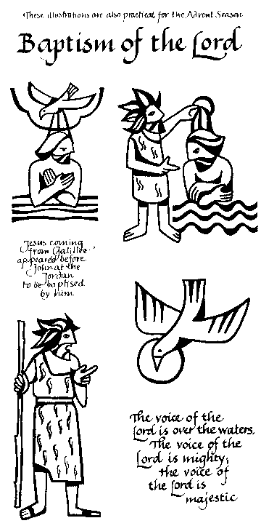

John testified, ‘I saw the Spirit descending from heaven like a dove, and it remained on him. I myself did not know him, but the one who sent me to baptize with water said to me, “He on whom you see the Spirit descend and remain is the one who baptizes with the Holy Spirit.” And I myself have seen and have testified that this is the Son of God.’

This is the Gospel of the Lord

**All: Praise to you, O Christ**

Priest: May God the Father,

who led the wise men by the shining of a star

to find the Christ, the Light from Light,

lead you also in your pilgrimage to find the Lord.

**All: Amen.**

Priest: May God the Son,

who turned water into wine at the wedding feast at Cana,

transform your lives and make glad your hearts.

**All: Amen.**

Priest: May God the Holy Spirit,

who came upon the beloved Son

at his baptism in the river Jordan,

pour out his gifts on you

who have come to the waters of new birth.

**All: Amen.**

Priest: And the blessing of God almighty,

the Father, the Son, and the Holy Spirit,

be among you and remain with you always.

**All: Amen.**

**Recessional hymn:** 84 ‘Brightest and best of the sons of the morning’

Priest: We have come to Christ, the living water.

Go in joy and peace to love and serve the Lord.

**All: In the name of Christ. Amen.**

✠ ✠ ✠ ✠ ✠ ✠ ✠ ✠ ✠ ✠ ✠ ✠ ✠ ✠ ✠ ✠ ✠ ✠ ✠ ✠ ✠ ✠ ✠ ✠ ✠ ✠ ✠ ✠ ✠ ✠ ✠ ✠ ✠ ✠ ✠

**Services and Notices for the week:**

Tues 8th 1.30pm Governors’ meeting at SMILE centre - MATs

7.00pm Parish Office and Choir Practice

Weds 9th 1.30pm Funeral of Tom Wilcock

5.00pm Curriculum and Data meeting in school

7.00pm Eucharist

Thurs 10th 10.30am Eucharist

8.00pm Thursday Ladies' Club meeting at the vicarage

**Next Sunday The Baptism of Christ**

**(13th Jan) 10.00am Sung Eucharist**

**Tea and Coffee:** served after the service – do please join us.

**PCC meeting:** advance notice of the meeting to be held on Tuesday 15th January at 8.00pm. Accounts will be available for perusal as soon as possible.

**Epiphany 6th January 2019**

Priest: On this great day, the Wise Men knelt before our Saviour. Let us also kneel to worship him with great joy, and to make our prayer to his heavenly Father.

(All kneel)

Leader: Father, the Wise Men came from the east to worship your Son:

grant to Christians everywhere a true spirit of adoration.

Leader: Lord, in your mercy

**All: Hear our prayer.**

Leader: Father, you are the King of kings and Lord of lords:

grant an abundance of peace to your world.

Hear our prayers for the people of Syria and Yemen.

Leader: Lord, in your mercy

**All: Hear our prayer.**

Leader: Father, the Holy Family shared the life of the people of Nazareth:

protect in your mercy our neighbours and our families.

Hear our prayers for the world-wide family,

and especially for those caught up in disaster and violence at this time.

Leader: Lord, in your mercy

**All: Hear our prayer.**

Leader: Father, though you were rich, for our sake you became poor:

show your love for the poor and powerless,

and strengthen the sick, including Karen Wilkinson, Joan Clegg, Norma Lee, Mark Shepherd, Marion Greatorex, Barbara Boscoe, Eileen Whitehead, Stephen Rawling, Stan Brand, Beryl Bentley, Maria Parkinson, Joyce Hetherington, Michael Thackeray, Callum Foy, Gladys Gardner, and all who suffer.

Leader: Lord, in your mercy

**All: Hear our prayer.**

Leader: Father, the Wise Men presented to your Son gold, frankincense and myrrh:

accept the gifts we bring, and the offering of our hearts at the beginning of this new year.

Leader: Lord, in your mercy

**All: Hear our prayer.**

Leader: Father, you are the King of heaven, the hope of all who trust in you:

give to those who have died recently – Wendy Edwards, Trent Tinsley-Wynn and Tom Wilcock – and to all the faithful departed, including Betty Hilton, May Blackmore, Joan Greatorex, Ivan Holloway, Ernest Best, Albert Best, Mary Cooper and Cyril Lees the wonders of your salvation.

Leader: Lord, in your mercy

**All: Hear our prayer.**

Leader: Rejoicing in the fellowship of wise men, shepherds, and angels,

and of the Blessed Virgin Mary and Saint Joseph,

we commend ourselves and all people to your unfailing love.

Merciful Father,

**All: accept these prayers,**

**for the sake of your Son,**

**our Saviour Jesus Christ. Amen.**

**Epiphany 6th January 2019**

**A reading from the book of the prophet Isaiah**

Arise, shine; for your light has come, and the glory of the LORD has risen upon you. For darkness shall cover the earth, and thick darkness the peoples; but the LORD will arise upon you, and his glory will appear over you. Nations shall come to your light, and kings to the brightness of your dawn. Lift up your eyes and look around; they all gather together, they come to you; your sons shall come from far away, and your daughters shall be carried on their nurses’ arms. Then you shall see and be radiant; your heart shall thrill and rejoice, because the abundance of the sea shall be brought to you, the wealth of the nations shall come to you. A multitude of camels shall cover you, the young camels of Midian and Ephah; all those from Sheba shall come. They shall bring gold and frankincense, and shall proclaim the praise of the LORD.

This is the word of the Lord.

**Thanks be to God.**

**Hymn:**  83 ‘As with gladness men of old’

***Second reading on next page /***

**A reading from the letter of Paul to the Ephesians**

I Paul, am a prisoner for Christ Jesus for the sake of you Gentiles – for surely you have already heard of the commission of God’s grace that was given me for you, and how the mystery was made known to me by revelation, as I wrote above in a few words, a reading of which will enable you to perceive my understanding of the mystery of Christ. In former generations this mystery was not made known to humankind, as it has now been revealed to his holy apostles and prophets by the Spirit: that is, the Gentiles have become fellow-heirs, members of the same body, and sharers in the promise in Christ Jesus through the gospel. Of this gospel I have become a servant according to the gift of God’s grace that was given me by the working of his power. Although I am the very least of all the saints, this grace was given to me to bring to the Gentiles the news of the boundless riches of Christ, and to make everyone see what is the plan of the mystery hidden fo r ages in God who created all things; so that through the church the wisdom of God in its rich variety might now be made known to the rulers and authorities in the heavenly places. This was in accordance with the eternal purpose that he has carried out in Christ Jesus our Lord, in whom we have access to God in boldness and confidence through faith in him.

This is the word of the Lord.

**Thanks be to God.**

At the offering of Gold:

Blessed are you, Lord our God, King of the Universe:

to you be praise and glory for ever!

As gold in the furnace is tried

and purified seven times in the fire,

so purify our hearts and minds

that we may be a royal priesthood

acceptable in the service of your kingdom.

All: Blessed be God for ever!

At the offering of Incense:

Blessed are you, Lord our God, King of the Universe:

to you be praise and glory for ever!

As our prayer rises up in your presence as incense,

so may we be presented before you

with penitent hearts and uplifted hands

to offer ourselves in your priestly service.

All: Blessed be God for ever!

At the offering of Myrrh:

Blessed are you, Lord our God, King of the Universe:

to you be praise and glory for ever!

As you give medicine to heal our sickness

and the leaves of the tree of life

for the healing of the nations,

so anoint us with your healing power

that we may be the first-fruits of your new creation.

**All: Blessed be God for ever!**

**After Communion:**

Priest: Let us pray:

Lord God, the bright splendour whom the nations seek: may we who with the wise men have been drawn by your light discern the glory of your presence in your Son, the Word made flesh, Jesus Christ our Lord. **Amen**

All: Almighty God, we thank you for feeding us with the body and blood of your Son, Jesus Christ. Through him we offer you our souls and bodies to be a living sacrifice. Send us out in the power of your Spirit to live and work to your praise and glory. Amen.

Priest: The Father’s voice bears witness to the Son.

**All: God has revealed himself to us.**

Priest: The Son bows his head beneath the waters of baptism.

**All: God has revealed himself to us.**

Priest: The Spirit as a dove descends from heaven.

**All: God has revealed himself to us.**

Priest: Submitting to John’s baptism, Christ delivers us from bondage.

**All: God has revealed himself to us.**

**The Dismissal Gospel**

Hear the Gospel of our Lord Jesus Christ according to John *(Jn 1. 32-34)*

**All: Glory to you, O Lord.**

John testified, ‘I saw the Spirit descending from heaven like a dove, and it remained on him. I myself did not know him, but the one who sent me to baptize with water said to me, “He on whom you see the Spirit descend and remain is the one who baptizes with the Holy Spirit.” And I myself have seen and have testified that this is the Son of God.’

This is the Gospel of the Lord

**All: Praise to you, O Christ**

Priest: May God the Father,

who led the wise men by the shining of a star

to find the Christ, the Light from Light,

lead you also in your pilgrimage to find the Lord.

**All: Amen.**

Priest: May God the Son,

who turned water into wine at the wedding feast at Cana,

transform your lives and make glad your hearts.

**All: Amen.**

Priest: May God the Holy Spirit,

who came upon the beloved Son

at his baptism in the river Jordan,

pour out his gifts on you

who have come to the waters of new birth.

**All: Amen.**

Priest: And the blessing of God almighty,

the Father, the Son, and the Holy Spirit,

be among you and remain with you always.

**All: Amen.**

**Recessional hymn:** 84 ‘Brightest and best of the sons of the morning’

Priest: We have come to Christ, the living water.

Go in joy and peace to love and serve the Lord.

**All: In the name of Christ. Amen.**